# PRACTICAL-5

**Aim:** Implement the given layout using Linear Layout.

## Design:

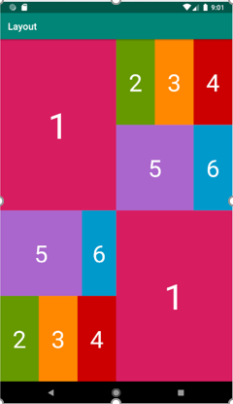

**Input (Xml Code):**

<?xml version="1.0" encoding="utf-8"?>

<androidx.constraintlayout.widget.ConstraintLayout xmlns:andr[oid="htt](http://schemas.android.com/apk/res/android)p:/[/sc](http://schemas.android.com/apk/res/android)he[mas.android.com/apk/res/android"](http://schemas.android.com/apk/res/android)

xmlns:app=["http://sc](http://schemas.android.com/apk/res-auto)h[emas.android.com/apk/res-auto"](http://schemas.android.com/apk/res-auto) xmlns:t[ools="ht](http://schemas.android.com/tools)tp:/[/sc](http://schemas.android.com/tools)he[mas.android.com/tools"](http://schemas.android.com/tools) android:layout_width="match_parent" android:layout_height="match_parent" tools:context=".MainActivity">

<LinearLayout android:id="@+id/linearLayout" android:layout_width="0dp" android:layout_height="0dp" android:orientation="vertical"

app:layout_constraintBottom_toBottomOf="parent" app:layout_constraintEnd_toEndOf="parent" app:layout_constraintStart_toStartOf="parent" app:layout_constraintTop_toTopOf="parent">

<LinearLayout android:layout_width="match_parent" android:layout_height="match_parent" android:layout_weight="1" android:background="#E91E63" android:orientation="horizontal">

<LinearLayout android:layout_width="match_parent" android:layout_height="match_parent" android:layout_weight="1">

<TextView android:id="@+id/textView2" android:gravity="center" android:layout_gravity="center" android:layout_width="wrap_content" android:layout_height="wrap_content" android:layout_weight="1" android:text="1" android:textColor="@color/white" android:textSize="50dp"

/>

</LinearLayout>

<LinearLayout android:layout_width="match_parent" android:layout_height="match_parent" android:layout_weight="1" android:background="@color/black" android:orientation="vertical">

<LinearLayout

android:layout_width="match_parent" android:layout_height="match_parent" android:layout_weight="1" android:background="@color/black" android:orientation="horizontal">

<LinearLayout android:layout_width="match_parent" android:layout_height="match_parent" android:layout_weight="1" android:background="#4CAF50" android:orientation="horizontal">

<TextView android:id="@+id/textView3" android:gravity="center" android:layout_gravity="center" android:layout_width="wrap_content" android:layout_height="wrap_content" android:layout_weight="1" android:text="2" android:textColor="@color/white" android:textSize="50dp"

/>

</LinearLayout>

<LinearLayout android:layout_width="match_parent" android:layout_height="match_parent" android:layout_weight="1" android:background="#FFEB3B" android:orientation="horizontal">

<TextView android:id="@+id/textView4"

android:gravity="center" android:layout_gravity="center" android:layout_width="wrap_content" android:layout_height="wrap_content" android:layout_weight="1" android:text="3" android:textColor="@color/white" android:textSize="50dp"

/>

</LinearLayout>

<LinearLayout android:layout_width="match_parent" android:layout_height="match_parent" android:layout_weight="1" android:background="#D61D1D" android:orientation="horizontal">

<TextView android:id="@+id/textView5" android:gravity="center" android:layout_gravity="center" android:layout_width="wrap_content" android:layout_height="wrap_content" android:layout_weight="1" android:text="4" android:textColor="@color/white" android:textSize="50dp"

/>

</LinearLayout>

</LinearLayout>

<LinearLayout android:layout_width="match_parent" android:layout_height="match_parent" android:layout_weight="1" android:background="@color/black" android:orientation="horizontal">

<LinearLayout android:layout_width="match_parent" android:layout_height="match_parent" android:layout_weight="1" android:background="#BB86FC" android:orientation="horizontal">

<TextView android:gravity="center" android:layout_gravity="center"

android:layout_width="wrap_content" android:layout_height="wrap_content" android:layout_weight="1" android:text="5" android:textColor="@color/white" android:textSize="50dp"

/>

</LinearLayout>

<LinearLayout android:layout_width="match_parent" android:layout_height="match_parent" android:layout_weight="2" android:background="#00BCD4" android:orientation="horizontal">

<TextView android:gravity="center"

android:layout_gravity="center" android:layout_width="wrap_content" android:layout_height="wrap_content" android:layout_weight="1" android:text="6" android:textColor="@color/white" android:textSize="50dp"

/>

</LinearLayout>

</LinearLayout>

</LinearLayout>

</LinearLayout>

<LinearLayout android:layout_width="match_parent" android:layout_height="match_parent" android:layout_weight="1" android:orientation="horizontal">

<LinearLayout android:layout_width="match_parent" android:layout_height="match_parent" android:layout_weight="1" android:orientation="vertical">

<LinearLayout android:layout_width="match_parent" android:layout_height="match_parent" android:layout_weight="1" android:orientation="horizontal">

<LinearLayout android:layout_width="match_parent" android:layout_height="match_parent"

android:layout_weight="1" android:background="@color/purple_200" android:orientation="horizontal">

<TextView android:gravity="center" android:layout_gravity="center"

android:layout_width="wrap_content" android:layout_height="wrap_content" android:layout_weight="1" android:text="5" android:textColor="@color/white" android:textSize="50dp"

/>

</LinearLayout>

<LinearLayout android:layout_width="match_parent" android:layout_height="match_parent" android:layout_weight="3" android:background="#00BCD4" android:orientation="horizontal">

<TextView android:gravity="center" android:layout_gravity="center"

android:layout_width="wrap_content" android:layout_height="wrap_content" android:layout_weight="1" android:text="6" android:textColor="@color/white" android:textSize="50dp"

/>

</LinearLayout>

</LinearLayout>

<LinearLayout android:layout_width="match_parent" android:layout_height="match_parent" android:layout_weight="1" android:orientation="horizontal">

<LinearLayout android:layout_width="match_parent" android:layout_height="match_parent" android:layout_weight="1" android:background="#4CAF50" android:orientation="horizontal">

<TextView android:gravity="center" android:layout_gravity="center"

android:layout_width="wrap_content" android:layout_height="wrap_content" android:layout_weight="1" android:text="2" android:textColor="@color/white" android:textSize="50dp"

/>

</LinearLayout>

<LinearLayout android:layout_width="match_parent" android:layout_height="match_parent" android:layout_weight="1" android:background="#FFEB3B" android:orientation="horizontal">

<TextView

android:gravity="center" android:layout_gravity="center" android:layout_width="wrap_content" android:layout_height="wrap_content" android:layout_weight="1" android:text="3" android:textColor="@color/white" android:textSize="50dp"

/>

</LinearLayout>

<LinearLayout android:layout_width="match_parent" android:layout_height="match_parent" android:layout_weight="1" android:background="#D61D1D" android:orientation="horizontal">

<TextView android:gravity="center" android:layout_gravity="center"

android:layout_width="wrap_content" android:layout_height="wrap_content" android:layout_weight="1" android:text="4" android:textColor="@color/white" android:textSize="50dp"

/>

</LinearLayout>

</LinearLayout>

</LinearLayout>

<LinearLayout

android:layout_width="match_parent" android:layout_height="match_parent" android:layout_weight="1" android:background="#E91E63" android:orientation="horizontal">

<TextView android:gravity="center" android:layout_gravity="center"

android:layout_width="wrap_content" android:layout_height="wrap_content" android:layout_weight="1" android:text="1" android:textColor="@color/white" android:textSize="50dp"

/>

</LinearLayout>

</LinearLayout>

</LinearLayout>

</androidx.constraintlayout.widget.ConstraintLayout>

## Output:

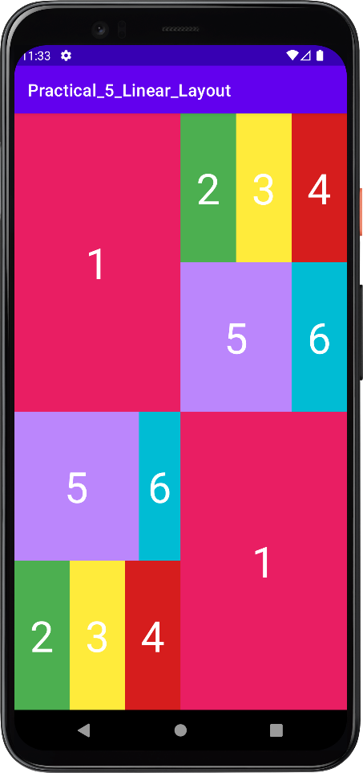

**Conclusion:** In this practical, we learned about linear layout, nested linear layout, layout gravity, orientation and text styles.